Guide to adding content to Terra Nova Australian Climate Change Adaptation Information Hub

Griffith University 2015. Guide to adding content to Terra Nova Australian Climate Change Adaptation Information Hub. Brisbane, Griffith University.

Prepared by: Rebecca Brown, Griffith University NRM CCAIMS Project
Last modified: 19 November 2015 (version 2.2)
© 2015 by Griffith University. Guide to adding content to Terra Nova Australian Climate Change Adaptation Information Hub is made available under a Creative Commons Attribution 4.0 International License. http://creativecommons.org/licenses/by/4.0/

Table of Contents
1. Terra Nova: a brief description 3
2. What sort of content can be added to/found in Terra Nova? 3
3. Copyright issues 3
4. Recommended browsers 3
5. Accessing Terra Nova 4
6. Adding content to Terra Nova 4
6.1. Terra Nova Collections 4
6.2. Getting started 4
AAF Login 6
Site Login for non-AAF users 6
6.3. Filling in the upload (metadata) form 6
Types of metadata 7
Navigating through the metadata form 7
Mandatory/recommended/optional fields 7
Content metadata set 7
Detailed Descriptions metadata set 8
Geographic and Temporal Extents metadata set 9
Attributions and Constraints metadata set 10
6.4. Attaching content items to the record 11
Uploading files 11
Giving your content items a title 11
Limitations on file names 12
Linking to externally hosted items 12
6.5. Modifying records in Terra Nova 13
Editing the metadata in a record 13
Adding extra content items to a record 14
Removing content items from a record 14
Un-publishing (retracting) a record 15
Deleting a record 15

Terra Nova: a brief description
Terra Nova www.terranova.org.au is an online information hub for researchers and decision makers in the climate change adaptation research domain. Terra Nova focuses on information, data and tools that reach down to the local scale and are relevant to local governments and regional planning authorities.
Terra Nova provides a range of discovery tools to locate relevant research outputs, including spatial and temporal searches.
Users can deposit their research outputs, with associated metadata descriptions, into Terra Nova’s centrally managed storage infrastructure.
All Terra Nova content is easily accessible to search engines like Google. Metadata for Terra Nova Collections is syndicated to Research Data Australia.
Terra Nova also offers two climate adaptation response tools: SEQCARI, the South East Queensland Climate Change Adaptation Research Initiative decision support tool, and a Climate Model Data Browser.

What sort of content can be added to/found in Terra Nova?
Terra Nova has been designed to accept a wide variety of content items, including datasets, documents, images, maps, presentations and multimedia.
Content can be stored directly in Terra Nova, or a metadata-only record can be created that points to digital content stored elsewhere.
Terra Nova can also alert users to content that is not available online – for example non-digitised content or content that requires negotiated access.

Copyright issues
All metadata and content items stored in Terra Nova are fully open to the public. There is no facility to restrict access to content items.
This means that you must be the copyright holder, or have permission from the copyright holder (e.g. through a licence or written agreement), to upload and store content on Terra Nova.
Terra Nova encourages copyright holders to apply an open licence to their research outputs where possible (e.g. a Creative Commons licence) to enable the widest possible reuse of those outputs.
For more information on copyright and open licensing, see the fact sheet Open licensing of research outputs: a fact sheet for Natural Resource Management (NRM) projects, stored on Terra Nova.

Recommended browsers
Terra Nova functions best when accessed using the latest versions of following browsers:
- Apple Safari
- Mozilla Firefox
- Google Chrome
The use of Microsoft Internet Explorer is currently not recommended.

Accessing Terra Nova
Terra Nova is available at www.terranova.org.au .
All existing content and tools are freely accessible to the public (no login required).
To add new content to Terra Nova you will need either an AAF (Australian Access Federation) login (automatically created for all Australian University based researchers and CSIRO staff) or a local “Site” login which has been created for you.
If you are a non-AAF user who wishes to add content and you haven’t been issued a login, email the Terra Nova team: terranova@griffith.edu.au.

Adding content to Terra Nova

Terra Nova Collections
Terra Nova content is generally stored in Collections. Collections have been created to store sets of outputs from particular research projects or groups (e.g. the NCCARF National Climate Change Adaptation Research Facility Collection). There is also a general, un-categorised Collection, the Terra Nova Repository Collection. Only Terra Nova administrators have the permissions to create new Collections. To have a new Collection created for a set of project outputs, email the Terra Nova team: terranova@griffith.edu.au.

Getting started
To initiate the process, click either of the Share buttons.
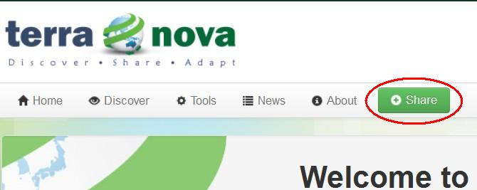

You will be prompted to select a Collection. You have the option of adding content to the Terra Nova Repository Collection (un-categorised) or selecting from the available Collections in the system. A Collection has been created for each of the Regional NRM Planning for Climate Change Fund projects. Scroll down to select the appropriate Collection, and click the Upload button.

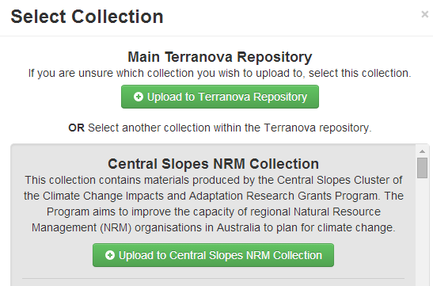

Once you have chosen a Collection, you will be prompted to log in.

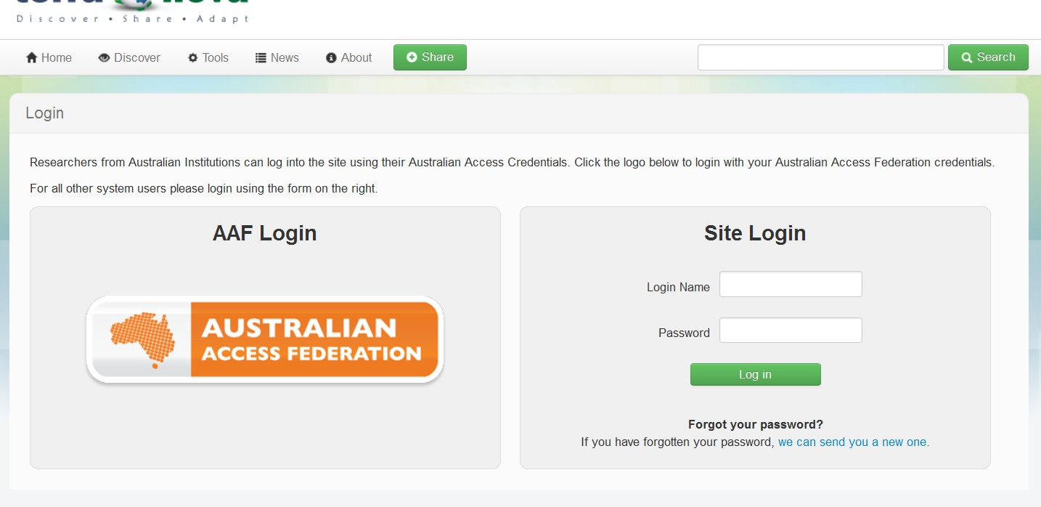

AAF Login
CSIRO and Australian university staff should log in using the AAF Login option. The AAF login will prompt you to enter the AAF organisation you belong to. You will then be presented with the login screen from your organisation. Use your normal organisation user name and password to log in.
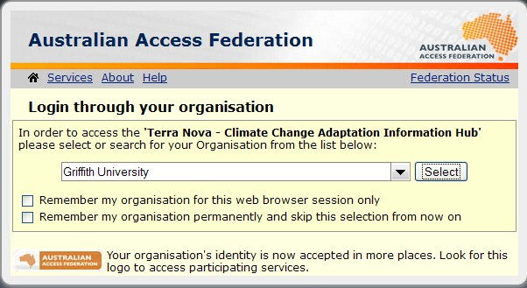

Site Login for non-AAF users
Other users (pre-approved staff from government organisations etc.) should use the Site Login option. If you are a non-AAF user who wishes to add content and you haven’t been issued a login, email the Terra Nova team on terranova@griffith.edu.au.

Filling in the upload (metadata) form
When you create a new record for a content item you can either:
- Fill out the metadata form to describe the content item, and store the item itself in Terra Nova; or
- Fill out the metadata form to describe the content item, store the item itself somewhere else (for example in an institutional repository), and provide Terra Nova users with a link to that item.
For more information on creating good metadata, see Creating metadata: a fact sheet for Natural Resource Management projects, stored on Terra Nova.

Types of metadata
The metadata form is made up of four sets of metadata fields: Content, Detailed Descriptions, Geographic and Temporal Extents, and Attributions and Constraints. Each set appears on a separate page.

Navigating through the metadata form
You can move forward through the metadata pages by clicking the Next button at the bottom of each set. You can also move back and forward through the metadata sets by clicking on the menu at the top right of the form (see image below).

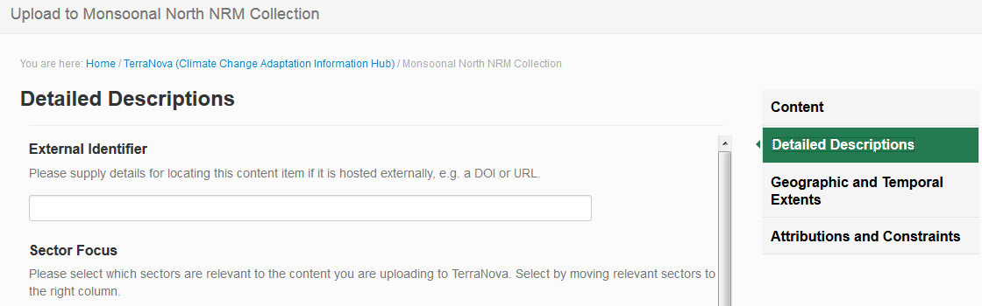

Mandatory/recommended/optional fields
All content items in Terra Nova require some standard metadata to appear, however there are not many mandatory fields. It is strongly recommended that you include the following information as a minimum: Title, Content Type, Brief Description, Owning Organisation, Geographic Coverage, NRM Region, Thematic Tags, Contributors, and Custodian. However you should only fill in fields if they are relevant to your content item.

Content metadata set
There are two mandatory fields on the first metadata page, the Title and the Statement of Expectations. If mandatory fields are left blank, you will get an error message when you try to save your record.
Title: mandatory, free text field.
Content Type: click in the box to choose from drop down list. It is possible to choose multiple content types, for example if you will be attaching a report and an associated dataset or map.
Brief Description: free text field
Detailed Summary: free text field
Owning Organisation: search or browse the list for the relevant publisher or owning organisation(s), then drag and drop to add. If the organisation you are looking for is not listed, leave blank. If you would like a new organisation listed, email the Terra Nova team: terranova@griffith.edu.au.
Logo: upload owning organisation’s logo as an image file, if desired.
Statement of Expectations: mandatory, tick the box to agree to the Statement of Expectations. If you don’t tick this box, you will get an error message when you try to save your record.
Upload Date: it is not necessary to add a date here, unless you want to apply an embargo to your record.
Once you have added all relevant metadata, click Next to move to the next page of the metadata form.
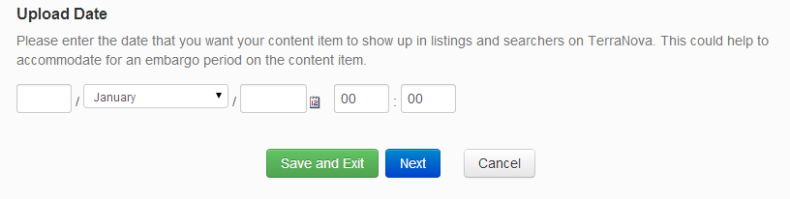

Detailed Descriptions metadata set
There are no mandatory fields on this page, however the use of Thematic Tags is recommended.
External Identifier: free text field; use if the content item is hosted at another internet address.
Sector Focus: choose one or more sectors from the left-hand box and click the arrow to move them to the right-hand box.
Thematic Tags: free text field; you can add multiple keywords. Some popular and relevant keywords (e.g. the ANZLIC keyword set) have been pre-loaded and will appear when you start to type a keyword.
Fields of Research (FOR): FOR codes have been pre-loaded. Start typing either a FOR code number or name. You can add multiple FOR codes.
Website: free text field; use if there is a website associated with the content item, e.g. a project or organisation website.
Once you have added all relevant metadata, click Next to move to the next page of the metadata form.

Geographic and Temporal Extents metadata set
There are no mandatory fields on this page, however the use of Geographic Coverage and Natural Resource Management Regions is recommended.
Geographic Coverage: can be added by either a) specifying a geographic area on the map by using drawing tools to draw a bounding box around the area; b) specifying a place on the map by typing a recognised placename into the Find places box; or c) entering manual coordinates into the Manual coordinates box in WKT format.
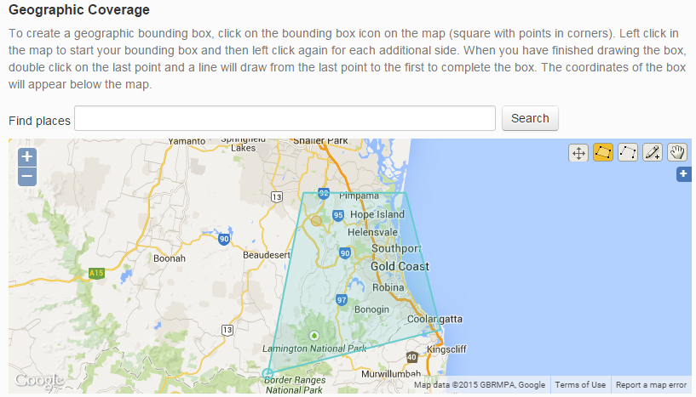

Local Government Areas: LGAs have been pre-loaded. Start typing the name of an LGA into the box to bring up a matching area. You can add multiple LGAs.
Natural Resource Management/ Local Land Service Regions: NRM and LLS regions have been pre-loaded. Start typing the name of a region into the box to bring up matching regions. Currently both pre-September 2014 and current regions are listed. You can add multiple regions. A map of NRM/LLS regions can be found at http://nrmregionsaustralia.com.au/nrm-regions-map/
Bioregions (IBRA): Bioregions have been pre-loaded. Start typing the name of a bioregion to bring up a matching region. You can add multiple bioregions. A map of IBRAs can be found at www.environment.gov.au/land/nrs/science/ibra/australias-bioregions-maps
Temporal Coverage: The time period during which the content item data was collected or relevant observations were made. This field will be most relevant when uploading datasets or projections data. Enter start and end dates in the format dd/mm/yyyy. For projections, enter end date as projection date, e.g. for 2050 projections enter 31/12/2050.
Once you have added all relevant metadata, click Next to move to the next page of the metadata form.

Attributions and Constraints metadata set
There are no mandatory fields on this page, however the use of Contributors, Custodian and Issue Date is recommended.
Rights: provide a rights statement and/or licensing details which outline the appropriate use of this content item. Terra Nova encourages the use of open licensing where possible. If you don’t use a licence on your content item, reuse of the item by third parties will be limited to those permissions set out under the Copyright Act 1968. For more information on copyright and licensing, see Open licensing of research outputs: a fact sheet for Natural Resource Management (NRM) projects, stored on Terra Nova.
Contributors: the names of people who contributed to the development of the content item. This could be authors, data collectors or other creators.
Citation: the way you would like the content item to be cited. You may choose your preferred referencing style. For datasets it is recommended to use the format Creator (PublicationYear): Title. Version*. Publisher. Resource Type*. Identifier. (*optional)
Custodian: enter the name and contact details of the person who can respond to queries about the content item. This field is of particular importance to datasets.
Expiration Date: enter a date into this field if your item has a limited life and you would like it removed after a particular date.
Issue Date: enter the date your item was published or otherwise formally issued. You can enter using the formats dd/mm,yyyy, mm,yyyy or yyyy.
Once all relevant metadata has been added to the record, save the record by using the Save and Exit button at the bottom of any of the pages. Once you click Save and Exit, your record is immediately published and will be viewable by all Terra Nova users (unless you have entered an Upload Date for some time in the future).

Attaching content items to the record
Once you have finished filling out the metadata form, your completed record will be displayed and you can add one or more files to the record (i.e. store the content item in Terra Nova). You can add multiple files to a single record, for example a report with accompanying maps, a collection of newsletters, a series of images, a dataset with an accompanying explanatory text file.

Uploading files
Upload options are located on the bottom right hand side of the screen. You can either drag the files to the Upload Files button or click on Browse and navigate to the files you wish to upload. You can add multiple files at once.
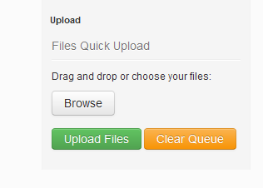

Giving your content items a title
You will be given the option to give the files a user-friendly title. If you don’t specify a title, the file name will automatically display. Click on Upload Files to start the file upload.
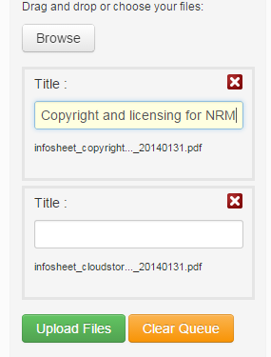

Limitations on file names
Currently Terra Nova only reads the first 56 characters of a file name (including the file extension). This means that if you upload 2 files with the same first 56 characters in their names, Terra Nova will think you are adding the same file twice, and will overwrite the first file. An example of this would be a 2 volume report with the file names Buyers Beware: a report into climate change impacts in South East Queensland volume 1.pdf and Buyers Beware: a report into climate change impacts in South East Queensland volume 2.pdf. To enable the successful upload of both volumes, this report would need to be retitled, e.g. Buyers Beware volume 1: a report into climate change impacts in South East Queensland.pdf and Buyers Beware volume 2: a report into climate change impacts in South East Queensland.pdf.

Linking to externally hosted items
Remember that if the content item you are describing is not to be stored in Terra Nova, you need to point users to it by filling in the External Identifier field in the metadata form. You may enter a DOI, a URI, URL or other identifier.

Modifying records in Terra Nova
It is possible to modify records you have created in Terra Nova. For example, you might wish to create a record with basic information about a content item, then come back and add more extensive metadata at a later stage. Alternatively, you might want to add extra files to a record once a project is finished, or replace a draft report with a final one.
To modify a record you have entered previously:
Log in to Terra Nova via the Log in button at the top right of the page.
Use the Discover or Search option to locate the relevant record.
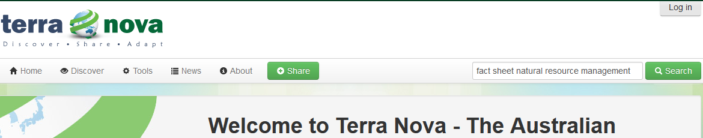

Editing the metadata in a record
To change or add information to the metadata record, click on the Edit tab to open the metadata entry form. You will only see the Edit tab if you are logged in with the same user credentials as when you originally created the record.

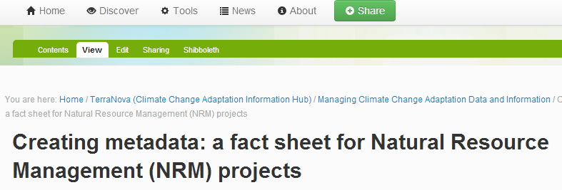

Make any necessary changes to the metadata, then click Save. See previous section, Filling in the upload (metadata) form for more details. You are also required to re-tick the Statement of Expectations box every time you edit a record.

Adding extra content items to a record
To add more content items to the record, use one of the upload options at the bottom right of the page. See previous section, Attaching content items to the record for more details.

Removing content items from a record
To remove a file from a record, click on the Contents tab. You will see a listing of all attached files. Tick the box next to the name of the file you want to remove, and click the Delete button. Adding or deleting files will not change the URL address of the metadata record.

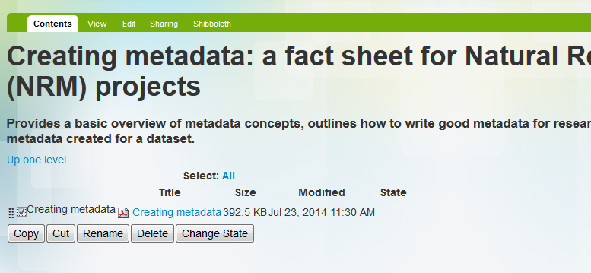

Un-publishing (retracting) a record
If you want to save a record without publishing it (for example if you want to come back later to add more metadata), or you want to retract a record, you can make the record private by choosing Retract from the State drop-down menu near the top right of the page. Private records are visible to you when you are logged in to the system, and to Terra Nova administrators, but won’t be visible to the public or other logged in users.
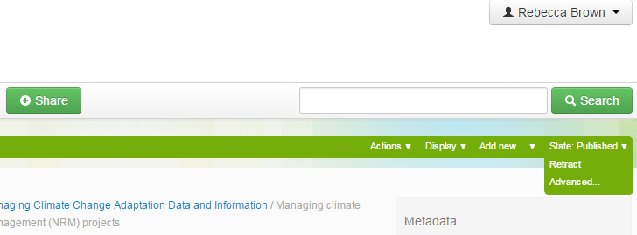

Once you are ready to publish the record, you will need to log in, navigate to the record, and choose Publish from the State drop down menu.

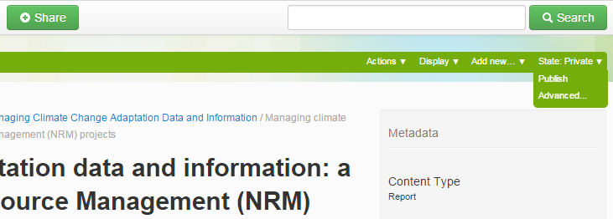

Deleting a record
Only system administrators can delete a record from Terra Nova. To remove a record from public view, follow the instructions in the previous section Unpublishing (retracting) a record. To have a record permanently deleted, email the Terra Nova team: terranova@griffith.edu.au.

